Bangladesh Medical Association (BMA)
List of Life Member-151
13. BMA Coxs Bazar Branch

Sl No | Voter No | Voter Details
1 | Voter No  LM-1300001  No Image | DR. MD. REZAUL KARIM (MONNO)  F/Name:  M/Name:  BM & DC Reg. No:  NID:  Cell:  Address:  Blood Group:
2 | Voter No  LM-1300002  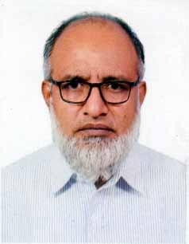 | DR. MD. MAHBUBUR RAHMAN  F/Name: Mozaffar Ahmed  M/Name: Nurzahan Begum  BM & DC Reg. No: A-17811  NID: 7768319837  Cell: +8801711722802  Address: Director, Doctors Chamber, Panbazar Road, Coxs Bazar-4700  Blood Group: O+
3 | Voter No  LM-1300003  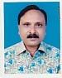 | DR. MOHD. SAIFUDDIN FARAZEE  F/Name: Mamtazul Hoque Farazee  M/Name:  BM & DC Reg. No:  NID:  Cell:  Address: Director  Doctors Chamber  Panbazar Road  Coxs Bazar  Blood Group:
4 | Voter No  LM-1300004  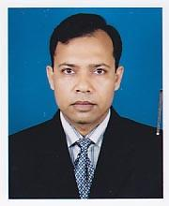 | DR. G.M. QUADERY  F/Name: M.a. Quadery  M/Name:  BM & DC Reg. No:  NID:  Cell:  Address: Director Doctors Chamber Panbazar Road Coxs Bazar  Blood Group:
5 | Voter No  LM-1300005  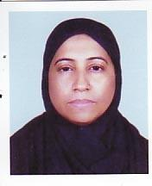 | DR. NAZIMA AKTER  F/Name: Mowlana Nasir Uddin  M/Name:  BM & DC Reg. No:  NID:  Cell:  Address: Enderson Road Coxs Bazar  Blood Group:
6 | Voter No  LM-1300006  No Image | DR. MD. SHAHJAHAN MAHMOOD  F/Name: Md. Abdus Salam  M/Name:  BM & DC Reg. No:  NID:  Cell:  Address:  Blood Group:
7 | Voter No  LM-1300007  No Image | DR. M. YOUSUF CHOWDHURY  F/Name:  M/Name:  BM & DC Reg. No:  NID:  Cell:  Address: National Pharmacy Main Road Cox's Bazar  Blood Group:  TRANSFERED to BMA Dhaka City  LM-1405543
8 | Voter No  LM-1300008  No Image | DR. MD. SHAHINUR RAHMAN  F/Name:  M/Name:  BM & DC Reg. No:  NID:  Cell:  Address:  Blood Group:  TRANSFERED to BMA Dhaka City  LM-1405543
9 | Voter No  LM-1300009  No Image | DR. SHAMIN FATEMA NARGIS  F/Name: Mr. Abdus Subhan  M/Name:  BM & DC Reg. No:  NID:  Cell:  Address:  Blood Group:
10 | Voter No  LM-1300010  No Image | DR. MD. BELAYET HOSSAIN  F/Name: Late Alhaj Momtajuddin Sheik  M/Name:  BM & DC Reg. No:  NID:  Cell:  Address: Civil Surgeon Coxs Bazar  Blood Group:
11 | Voter No  LM-1300011  No Image | DR. MD. ABDUL AWAL MIA  F/Name:  M/Name:  BM & DC Reg. No:  NID:  Cell:  Address:  Blood Group:  TRANSFERED to BMA Dhaka City  LM-1405543
12 | Voter No  LM-1300012  No Image | DR. AZM SHAKHAWAT HOSSAIN  F/Name: Dr. M A Quashem  M/Name:  BM & DC Reg. No:  NID:  Cell:  Address:  Blood Group:
13 | Voter No  LM-1300013  No Image | DR. MD. ZAHIRUDDIN  F/Name: Shamsuddin Ahmed  M/Name:  BM & DC Reg. No:  NID:  Cell:  Address: Junior Consultant Sadar Hospital Coxs Bazar  Blood Group:
14 | Voter No  LM-1300014 | DR. ARUP DUTTA  F/Name: Late Rabindra Lal Dutta  M/Name:  BM & DC Reg. No:  NID:  Cell:  Address: Consultant Paediatrics Coxsbazar Sadar Hospital Coxs Bazar  Blood Group:
15 | Voter No  LM-1300015  No Image | DR. MD. ABU TAHER  F/Name: Md. Hossain Shah  M/Name:  BM & DC Reg. No:  NID:  Cell:  Address: Teknaf Thana Health Complex Coxs Bazar  Blood Group:
16 | Voter No  LM-1300016  No Image | DR. MD. BADIUR RAHMAN  F/Name: Muhammad Ali  M/Name:  BM & DC Reg. No:  NID:  Cell:  Address: Ramo Upazila ,cox's Bazar  Blood Group:
17 | Voter No  LM-1300017  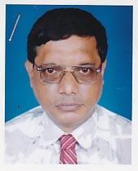 | DR. DULAL CHANDRA PAUL  F/Name: Late Jnanendra Bikash Paul  M/Name:  BM & DC Reg. No:  NID:  Cell:  Address: Ramu Health Complex, Coxs Bazar.  Blood Group:
18 | Voter No  LM-1300018  No Image | DR. MOHAMMAD RAFIQUL HASAN  F/Name: Late Alhaj Sultan Ahmed  M/Name:  BM & DC Reg. No:  NID:  Cell:  Address: Junior Consultant, Anaesthsia, Sadar Hospital, Coxs Bazar  Blood Group:
19 | Voter No  LM-1300019  No Image | DR. MOHD. IBRAHIM KHALIL ULLAH  F/Name: Mvi Ahmed Shafi  M/Name:  BM & DC Reg. No:  NID:  Cell:  Address: Hamida Mension Tarabaniar Chara Coxs Bazar  Blood Group:
20 | Voter No  LM-1300020  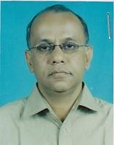 | DR. MD. NASIM HYDER  F/Name: Late A. F. M. Mostafa  M/Name:  BM & DC Reg. No:  NID:  Cell:  Address: CHEVRON, Coxs Bazar.  Blood Group:
21 | Voter No  LM-1300021 | DR. SHAFIQUL ISLAM  F/Name: Late Abdul Wazed Meah  M/Name:  BM & DC Reg. No:  NID:  Cell:  Address: Medical Officer Sadar Hospital, Coxs Bazar.  Blood Group:
22 | Voter No  LM-1300022  No Image | DR. MD. MOFIZUL ALAM  F/Name:  M/Name:  BM & DC Reg. No:  NID:  Cell:  Address:  Blood Group:  TRANSFERED to BMA Dhaka City  LM-1405543
23 | Voter No  LM-1300023  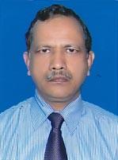 | DR. NURUL KARIM KHAN  F/Name: Late Solaiman Khan  M/Name:  BM & DC Reg. No:  NID:  Cell:  Address: Baitus Sharaf Shishu Hospital Coxs Bazar  Blood Group:
24 | Voter No  LM-1300024  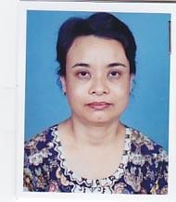 | DR. MA YIN NU  F/Name: Late U Sein  M/Name:  BM & DC Reg. No:  NID:  Cell:  Address: Medical Officer Sadar Hospital Coxs Bazar  Blood Group:
25 | Voter No  LM-1300025  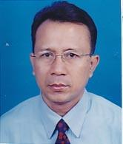 | DR. PU CHAW NU  F/Name: Late Ching Nai Mong  M/Name:  BM & DC Reg. No:  NID:  Cell:  Address: RMO, Sadar Hospital Coxs Bazar  Blood Group:
26 | Voter No  LM-1300026  No Image | DR. MOHAMMAD SAIFUL ISLAM  F/Name: Mohammad Noorul Islam  M/Name:  BM & DC Reg. No:  NID:  Cell:  Address: Medical Officer TB Clinic Coxs Bazar  Blood Group:
27 | Voter No  LM-1300027  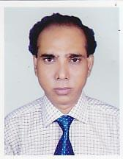 | DR. FARID UDDIN MD. OSMAN  F/Name: Dr. Syed Farrukh Ahmed  M/Name:  BM & DC Reg. No:  NID:  Cell:  Address: R. M. O. Ramu Health Complex Coxs Bazar  Blood Group:
28 | Voter No  LM-1300028  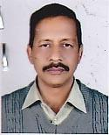 | DR. AJOY GHOSH  F/Name: Amrita Lal Ghosh  M/Name:  BM & DC Reg. No:  NID:  Cell:  Address: Ramu Thana Health Complex Coxs Bazar  Blood Group:
29 | Voter No  LM-1300029  No Image | DR. MUHAMMAD RASHID  F/Name: Late Hajee Sikander Ali  M/Name:  BM & DC Reg. No:  NID:  Cell:  Address: Medical Officer Ramu Thana Health Complex Coxs Bazar  Blood Group:
30 | Voter No  LM-1300030  No Image | DR. BISHWA KIRTY TRIPURA  F/Name: Late Vaghaban Chandra Tripura  M/Name:  BM & DC Reg. No:  NID:  Cell:  Address: Ramu Thana Health Complex Coxs Bazar  Blood Group:
31 | Voter No  LM-1300031  No Image | DR. PRAGATI CHAKMA  F/Name: Mr. Dayhl Mohan Chankma  M/Name:  BM & DC Reg. No:  NID:  Cell:  Address: Medical Officer Teknaf Health Complex Coxs Bazar  Blood Group:
32 | Voter No  LM-1300032  No Image | DR. MD. SHAH ALAM  F/Name: Mojammel Hoque Sikdar  M/Name:  BM & DC Reg. No:  NID:  Cell:  Address: RMO Rabita Hospital And Diagnostic Coxs Bazar  Blood Group:
33 | Voter No  LM-1300033  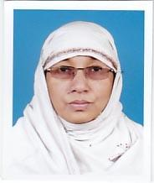 | DR. SHAMIM ARA NUR  F/Name: A. T. M. Syed Ahmed  M/Name:  BM & DC Reg. No:  NID:  Cell:  Address: Doctors Care Pan, Bazar Road, Coxs Bazar  Blood Group:
34 | Voter No  LM-1300034  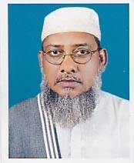 | DR. ABDUN NUR BULBUL  F/Name: Late Mr. Ahmad Kabir Chy  M/Name:  BM & DC Reg. No:  NID:  Cell:  Address: Doctors Care Pan Bazar Road Coxs Bazar  Blood Group:
35 | Voter No  LM-1300035  No Image | DR. SYED MESBAHUL HAQUE  F/Name:  M/Name:  BM & DC Reg. No:  NID:  Cell:  Address:  Blood Group:
36 | Voter No  LM-1300035  No Image | DR. SYED MESBAHUL HAQUE  F/Name:  M/Name:  BM & DC Reg. No:  NID:  Cell:  Address: A  Blood Group:
37 | Voter No  LM-1300036 | DR. ABDUL HASNAT MD. WAHEEDUL HAQUE  F/Name: Abu Md. Ezharul Hoque  M/Name:  BM & DC Reg. No: 20762  NID:  Cell:  Address: Medical Officer Sadar Hospital, Coxs Bazar.  Blood Group:
38 | Voter No  LM-1300037  No Image | DR. MD. MONIRUL ALAM  F/Name:  M/Name:  BM & DC Reg. No:  NID:  Cell:  Address: Medical Officer MCH & FPO Khagrachari  Blood Group:
39 | Voter No  LM-1300038  No Image | DR. KOHINOOR AKTER  F/Name:  M/Name:  BM & DC Reg. No:  NID:  Cell:  Address:  Blood Group:  TRANSFERED to BMA Dhaka City  LM-1405543
40 | Voter No  LM-1300039  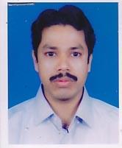 | DR. MOHIUDDIN MD. ALAMGIR  F/Name:  M/Name:  BM & DC Reg. No:  NID:  Cell:  Address: Medical Officer Sadar Hospital Coxs Bazar  Blood Group:
41 | Voter No  LM-1300040  No Image | DR. AKLIMA AKHTER BANU  F/Name: Md. Abdul Alep Miah  M/Name:  BM & DC Reg. No:  NID:  Cell:  Address: Medical Officer Maternity Clinic,Coxs Bazar.  Blood Group:
42 | Voter No  LM-1300041  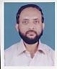 | DR. MD. AKTAR KAMAL  F/Name: Late Md. Abdus Salam  M/Name:  BM & DC Reg. No: 13243  NID:  Cell:  Address: ENT Department Sadar Hospital Coxs Bazar  Blood Group:
43 | Voter No  LM-1300042  No Image | DR. MUZIBUR RAHMAN  F/Name: Late Md. Abdul Matin  M/Name:  BM & DC Reg. No:  NID:  Cell:  Address: N/A  Blood Group:
44 | Voter No  LM-1300043  No Image | DR. MD. HABIBUR RAHMAN  F/Name: Late Md. Ali Akbar  M/Name:  BM & DC Reg. No:  NID:  Cell:  Address: Consultant (Medicine) Sadar Hospital Coxs Bazar  Blood Group:
45 | Voter No  LM-1300044  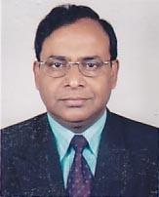 | DR. BIMAL KANTI CHOWDHURY  F/Name: Abirath Chowdhury  M/Name:  BM & DC Reg. No:  NID:  Cell:  Address: Consultant Eye Dept. Community Eye Hosptial, Pan Bazar Coxs Bazar.  Blood Group:
46 | Voter No  LM-1300045  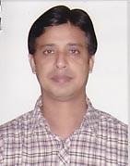 | DR. MOHAMMED NURUL ALAM  F/Name: Dr. Anwar Ahmed  M/Name:  BM & DC Reg. No:  NID:  Cell:  Address: Shevron Building Hospital Road Coxs Bazar  Blood Group:
47 | Voter No  LM-1300046 | DR. MISBAH UDDIN AHMED  F/Name: Badrul Amin  M/Name:  BM & DC Reg. No:  NID:  Cell:  Address: Chevron Lab Coxs Bazar  Blood Group:
48 | Voter No  LM-1300047  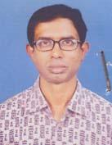 | DR. KHONDAKAR ASADUZZAMAN  F/Name: Late Khondkar Afsar Uddin  M/Name: Mosammad Nurjahan Begum  BM & DC Reg. No: 17295  NID: 1594116396951  Cell: 01711487864  Address: Ramu Upazila Health Complex Cox\'s Bazar  Blood Group: B+
49 | Voter No  LM-1300048  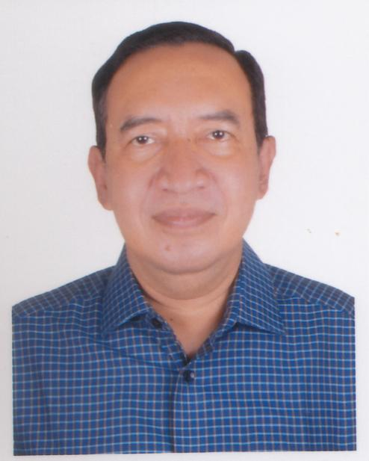 | DR. SUNAYAN BARUA  F/Name: Mrinal Barua  M/Name: Dipti Barua  BM & DC Reg. No: 21365  NID: 284 662 1395  Cell: 01816244168  Address: Doctor's Chamber Pan Bazar Road, Cox's Bazar  Blood Group: A+
50 | Voter No  LM-1300049  No Image | DR. MOHIUDDIN MOHAMMAD ALAMGIR  F/Name: Nur Mohammad Advocate  M/Name:  BM & DC Reg. No: 24913  NID:  Cell:  Address: Vill: Shikolbaha, Thana: Potiya, Dist: Chittagong  Blood Group:
51 | Voter No  LM-1300050  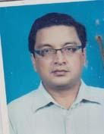 | DR. MOHAMMED ATAUR RAHMAN  F/Name: Md. Abdus Salam  M/Name: Mrs. Ataharun Nesa  BM & DC Reg. No: 27746  NID: 1592827107813  Cell: 01714575551  Address: Chevron Hospital Road, Cox's Bazar  Blood Group: O+
52 | Voter No  LM-1300051  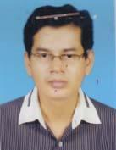 | DR. ASIT KUMAR MONDOL  F/Name: Kumud Ranjan Mondol  M/Name: Nila Boty Mondal  BM & DC Reg. No: 40549  NID: 2219031641125  Cell: N/A  Address: Islam Bhaban (2nd Floor) Central Mosque Road Cox's Bazar  Blood Group: A-
53 | Voter No  LM-1300052  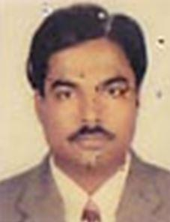 | DR. RAFI AHMED  F/Name: Benazir Ahmed  M/Name:  BM & DC Reg. No: 14057  NID:  Cell:  Address: Junior Conseltant ( Ortho. Surgery), District Sadar Hospital, Cox’s Bazar.  Blood Group:
54 | Voter No  LM-1300053  No Image | DR. B.M. ALI YOUSUF  F/Name: Late Md. Gohar Ali Biswa  M/Name:  BM & DC Reg. No:  NID:  Cell:  Address: Principal, Cox’s Bazar Medical College, Cox’s Bazar.  Blood Group:
55 | Voter No  LM-1300054  No Image | DR. MOHAMMED JAHANGIR KABIR BHUIYAN  F/Name: Mohammed Salamat Ullah  M/Name:  BM & DC Reg. No:  NID:  Cell:  Address: Junior Colsultant Surgery Sadar Hospital. Cox’s Bazar.  Blood Group:
56 | Voter No  LM-1300055  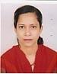 | DR. MANAWARA SULTANA  F/Name: Md. Mahabubur Rahaman  M/Name:  BM & DC Reg. No:  NID:  Cell:  Address: Junior Colsultant Gyeny Sadar Hospital. Cox’s Bazar.  Blood Group:
57 | Voter No  LM-1300056  No Image | DR. MD. MAHBUBUL ALAM  F/Name: Nazir Ahmed  M/Name:  BM & DC Reg. No:  NID:  Cell: 01914893314  Address: “Probal”, West Of Hotel Niribily North Baharhara, Cox’s Bazar  Blood Group:
58 | Voter No  LM-1300057  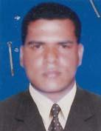 | DR. TITO CHANDRA SHIL  F/Name: Late Babul Chandra Shil  M/Name: Late Joshna Bala Shil  BM & DC Reg. No: 44808  NID: 4624907211742  Cell: 01819369262  Address: Medical Officer Upazila Health Complex, Teknaf,Cox's Bazar  Blood Group: A+
59 | Voter No  LM-1300058  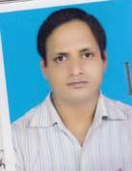 | DR. MOHAMMAD HUMAYUN KABIR  F/Name: Khurshid Alam  M/Name: Rasheda Begum  BM & DC Reg. No: 32009  NID: 1518236115290  Cell: 01712052322  Address: Samura Nishad, Master Farrukh Ahmad Lane North Rumaliarchara, Cox's Bazar  Blood Group: O+
60 | Voter No  LM-1300059  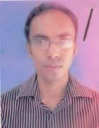 | DR. AYET ULLAH  F/Name: Rahamat Ullah  M/Name: Monowara Begum  BM & DC Reg. No: 47653  NID: 9196203131454  Cell: 01749313475  Address: UHC, Teknaf, Cox's Bazar  Blood Group: A+
61 | Voter No  LM-1300060  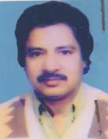 | DR. ABUL KALAM AZAD  F/Name: Late Zoyenuddin Munshi  M/Name: Late Asia Begum  BM & DC Reg. No: 14179  NID: 2222403347915  Cell: 01715050955  Address: Cox Bazar Medicla College  Blood Group: B+
62 | Voter No  LM-1300061 | DR. MOHAMMAD YUNUS  F/Name: Akter Ahmed  M/Name: Baduzzamal  BM & DC Reg. No: 30596  NID: 2697556418151  Cell: 01552201214  Address: Cox's Bazar Medical College  Blood Group: B+
63 | Voter No  LM-1300062  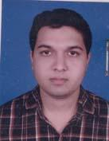 | DR. MD. SAIFUL ISLAM  F/Name: Md. Nurul Hoque  M/Name: Shahnewaz Hoque  BM & DC Reg. No: 55212  NID: 2694811023278  Cell: N/A  Address: Mouchak, Aggriculture Office Road (Level-2) Cox\'s Bazar-4700  Blood Group: O+
64 | Voter No  LM-1300063  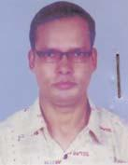 | DR. OSMANUR RASHID  F/Name: Abdul Khaleque  M/Name: Umme Habiba  BM & DC Reg. No: 30989  NID:  Cell: 01841062096  Address: B/5, Doctor's Quarter, Cox's Bazar  Blood Group: A-
65 | Voter No  LM-1300064  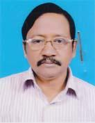 | DR. SULTAN AHMED SIRAJEE  F/Name: Hazee Abdus Sukkur  M/Name: Mrs. Nashima Khatun  BM & DC Reg. No: 16155  NID: 38095  Cell: 01819721163  Address: R.M.O, Sadar Hospital, CoxBazar  Blood Group: AB+
66 | Voter No  LM-1300065  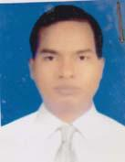 | DR. MUHAMMAD AMZAD HUSSAIN  F/Name: Alhaj Mujaher Mia  M/Name: Mabia Khatun  BM & DC Reg. No: 29932  NID: 2224902104536  Cell: 01711134274  Address: Medical Officer, Sadar Hospital, Cox's Bazar  Blood Group: AB+
67 | Voter No  LM-1300066  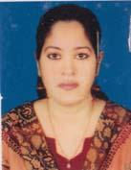 | DR. NAHIDA PERVIN  F/Name: Alhaj Md. Abdul Mannan  M/Name: Ayesha Begum  BM & DC Reg. No: 39840  NID: 2224902104535  Cell: 01711134274  Address: Medical Officer, HR-STEP Sadar Hospital, Cox's Bazar  Blood Group: O+
68 | Voter No  LM-1300067  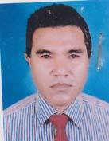 | DR. MOHAMMAD SHAMSUL HUDA  F/Name: Late Alhaj Sekander  M/Name: Late Altaj Begum  BM & DC Reg. No: 19522  NID:  Cell: 01815812606  Address: Metro Diagonestic Centre, DC Road, Eidgah Bazar, Cox's Bazar  Blood Group: B+
69 | Voter No  LM-1300068  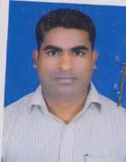 | DR. RUPASH PAUL  F/Name: Dr. Dinabandhu Paul  M/Name: Anchana Paul  BM & DC Reg. No: 41995  NID: 2212435439384  Cell: 01723969984  Address: Seba Diagnostic Centre, Eadgha Chaol Bazar Road, Eadgha Bazar, Cox\'s Bazar  Blood Group: O+
70 | Voter No  LM-1300069  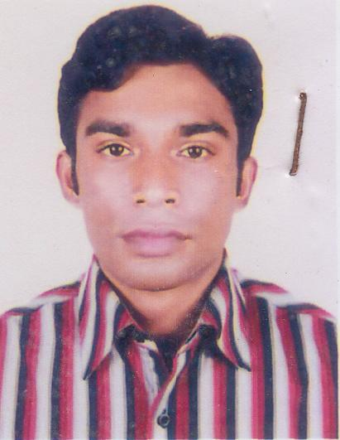 | DR. NOBEL KUMAR BARUA  F/Name: Sunil Kumar Barua  M/Name: Sebika Barua  BM & DC Reg. No: 47865  NID:  Cell: 01732311621  Address: Konika Bhqabon, Ward No. 10 Cox’s Bazar paurashava, Cox’s Bazar.  Blood Group:
71 | Voter No  LM-1300070  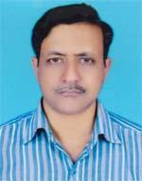 | DR. BIDHAN PAUL  F/Name: Sadhan Paul  M/Name: Kalpana Paul  BM & DC Reg. No: 30240  NID: 2222408362961  Cell: 01716843080  Address: JR. Consultant, Dist. Sadar Hospital, Coxsbazar  Blood Group: O+
72 | Voter No  LM-1300071 | DR. MOHAMMAD ARIF HOSSAIN  F/Name: Ahmed Hossain  M/Name: Sajia Begum  BM & DC Reg. No: 35590  NID: 2696653276499  Cell: 01818650463  Address: Junior Consultant (Surgery), District Sadar Hospital, Coxsbazar  Blood Group: B+
73 | Voter No  LM-1300072 | DR. ARIFUR RAHAMAN  F/Name: Late Mustafizur Rahman  M/Name: Bilkis Jahan Khanam  BM & DC Reg. No: 29514  NID: 2222405379303  Cell: 01749165131  Address: Jahan mansion, New Chowdhury para, Ward No.-05, Coxsbazar Sadar, Coxsbazar  Blood Group: A+
74 | Voter No  LM-1300073  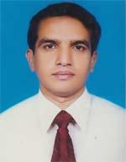 | DR.MOHAMMED NURUL ALAM  F/Name: Hazi Abdus Samad  M/Name: Safura Khatun  BM & DC Reg. No: 30743  NID:  Cell: N/A  Address: Asst. Prof. Coxsbazar Medical College , Coxsbazar  Blood Group: A+
75 | Voter No  LM-1300074 | DR. TAJINA SHARMIN  F/Name: Taher Uddin Ahmed  M/Name: Razia Ahmed  BM & DC Reg. No: 29515  NID: 2222405379304  Cell: 01711379304  Address: Jahan mansion, New Chowdhury Para, Ward-05, Coxsbazar Sadar, Coxsbazar  Blood Group: A+
76 | Voter No  LM-1300075  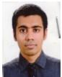 | DR. MUSHNAD QUADERY  F/Name: Gm Quadery  M/Name: Dr Nazma Akter  BM & DC Reg. No: 78734  NID: 19932222403000010  Cell: 01678144144  Address: 36/2 Badar Mokam Cox's Bazar.  Blood Group: O+
77 | Voter No  LM-1300076  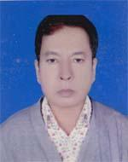 | DR. ATA-I-ELAHI  F/Name: Late Suja Uddin  M/Name: Late Anjoman Ara Begum  BM & DC Reg. No: 11781  NID: 2221604160083  Cell: 01815152316  Address: Haspital para, 4 No. Hara, Post-Chesinga, Chakatia Pourashova, Coxs Bazar  Blood Group: A+
78 | Voter No  LM-1300077  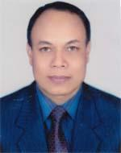 | DR. ABUL BARKAT MUHAMMAD ADNAN  F/Name: Abul Hashem  M/Name: Hasiba Khanam  BM & DC Reg. No: 21687  NID: 2694814913208  Cell: 01843559911  Address: Coxs bazar Medical College, Coxs Bazar  Blood Group: O+
79 | Voter No  LM-1300078  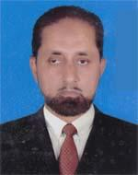 | DR. S M ABU SAYEED  F/Name: Late Emdad Hossen  M/Name: Late Nurunnahar Begum  BM & DC Reg. No: 14050  NID: 1514762080896  Cell: 01818126322  Address: Super, Zilla Sadar Hospital, Coxsbazar  Blood Group: n_a
80 | Voter No  LM-1300079 | DR. MOHAMMAD FARIDUL HOQUE  F/Name: Karim Dad  M/Name: Mahafuza Begum  BM & DC Reg. No: 30795  NID: 2222409366260  Cell: 01711469092  Address: Junior Consultant, Coxs Bazar Medical College, Coxs Bazar  Blood Group: O+
81 | Voter No  LM-1300080 | DR. S. M. ZAMSADUL HOQ  F/Name: Md. Sirajul Hoque  M/Name: Mrs. Tahera Begum  BM & DC Reg. No: 57110  NID: 2222403396978  Cell: 01816233472  Address: Siraj Mansion, Panbazar, Nurpara, Coxsbazar  Blood Group: B-
82 | Voter No  LM-1300081 | DR. ABU MOHAMMAD TAREK ADNAN  F/Name: Mahabubul Hoque  M/Name: Kohinur Begum  BM & DC Reg. No: 75600  NID: 19872222403000002  Cell: 01712207324  Address: Feroza Shopping Complex, Pan Bazar Road, Coxs Bazar  Blood Group: AB+
83 | Voter No  LM-1300082 | DR. ANNY PAUL  F/Name: Badal Kanti Paul  M/Name: Dipti Paul  BM & DC Reg. No: 66257  NID: 19882222410000001  Cell: 01723676605  Address: Bangapahar, Hospital Road, Coxs Bazar  Blood Group: A+
84 | Voter No  LM-1300083  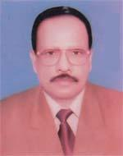 | DR. ABDUL MABUD  F/Name: Late Alhaz Shahab Uddin  M/Name: Late Salma Khatun  BM & DC Reg. No: 14521  NID: 1510466767696  Cell: 01969655773  Address: Chiringa, Chakaria Pawrashaur, Chakaria, Coxs Bazar  Blood Group: AB+
85 | Voter No  LM-1300084 | DR. MOHAMMAD HOQUE  F/Name: Alhaj Zafarul Hoque  M/Name: Almas Khatun  BM & DC Reg. No: 37701  NID: 0315305338772  Cell: 01718501650  Address: Doctors Quarter , UHC, Chakaria, Coxs Bazar  Blood Group: O+
86 | Voter No  LM-1300085  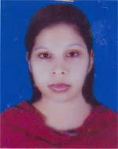 | DR. ROWSHAN JAHAN URME  F/Name: Md. Shohab Uddin  M/Name: Khaleda Begum  BM & DC Reg. No: 55078  NID: 1591017603378  Cell: 01720179071  Address: Medical officer FDSR Chokonia  Blood Group: A+
87 | Voter No  LM-1300086  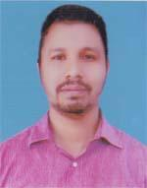 | DR. SYED MOHAMMAD SARWAR  F/Name: Syed Mohammad Habibullah  M/Name: Khurshida Begum  BM & DC Reg. No: 36143  NID: 1591905739180  Cell: 01720150131  Address: Otobi-6, New Circuit House Road, Coxs Bazar,  Blood Group: A+
88 | Voter No  LM-1300087  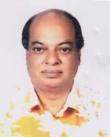 | DR. MD. MAHBUBUL ALAM  F/Name: Late Janab Fazlul Karim  M/Name: Late Janaba Dilsafa Begum  BM & DC Reg. No: 9283  NID: 2221604160025  Cell: 01819848223  Address: Hospital Road, Chakais, Coxs Bazar  Blood Group: O+
89 | Voter No  LM-1300088 | DR. MD. YASIR ARAFAT  F/Name: Md. Akman Ali  M/Name: Khodeza Khatun  BM & DC Reg. No: 44299  NID: 19812696653268883  Cell: 01979123479  Address: 3B, J.S Bhaban, Kobarstan Road, South Tara Bonia Chora, Coxs Bazar  Blood Group: A+
90 | Voter No  LM-1300089 | DR. MUSFIKAH RAHMAN FERDAUSHI  F/Name: Md. Motiur Rahman  M/Name: Lutfunnesa  BM & DC Reg. No: 42393  NID: 1591905739181  Cell: 01712000951  Address: Otobi-6, officer Quarter, New Circuit House Road, Coxs Bazar  Blood Group: O+
91 | Voter No  LM-1300090 | DR. MD. JAMSHED GIAS UDDIN  F/Name: Late Md. Shamsul Hoque  M/Name: Mrs. Hashina Sultana  BM & DC Reg. No: 64799  NID: 1916765152666  Cell: 01816251351  Address: Asst. Register, (Surgery), Coxs Bazar Sadar Hospital.  Blood Group: O+
92 | Voter No  LM-1300091 | DR. MD. SAIFUL ISLAM  F/Name: Amirul Hoque  M/Name: Syesta Khanom  BM & DC Reg. No: 42654  NID: 2222408375200  Cell: 01712528644  Address: Baihush Sharaf Hospital , Coxs Bazar  Blood Group: O+
93 | Voter No  LM-1300092  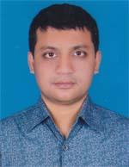 | DR. SALIM ULLAH KHAN  F/Name: Syed Ahamed  M/Name: Asia Begum  BM & DC Reg. No: 35309  NID: 2222403336153  Cell: 01711440313  Address: Nabab Market, Bara Bazar, Coxs Bazar  Blood Group: O+
94 | Voter No  LM-1300093  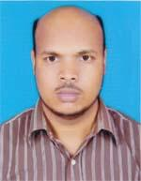 | DR. MD. ABDUL AWAL PRAMANIK  F/Name: Late Md. Fazlur Rahman Pramanik  M/Name: Mrs. Alepzan Begum  BM & DC Reg. No: 29113  NID: 2222410360083  Cell: 01814805469  Address: Contral Hospital, Coxs Bazar  Blood Group: B+
95 | Voter No  LM-1300094  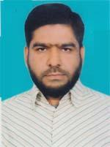 | DR. ABDUL MANNAN  F/Name: Abdul Gani  M/Name: Madan Sair  BM & DC Reg. No: 31798  NID: 1595708510545  Cell: 01818120180  Address: Uh & Fpo, Ramu, Coxs Bazar  Blood Group: O+
96 | Voter No  LM-1300095  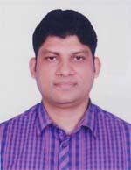 | DR. MD. SHAHEEN ABDUR RAHMAN CHOWDHURY  F/Name: Md. Abul Bashar Chowdhury  M/Name: Mrs. Kamrunnesa  BM & DC Reg. No: 41099  NID: 1595708571010  Cell: 01816438400  Address: Kutub house, Baharchara, Sadar, Coxs Bazar  Blood Group: O+
97 | Voter No  LM-1300096  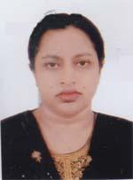 | DR. LUTFUN NAHAR BEGUM  F/Name: A. K. M. Aman Ullah  M/Name: Late Nurun Nahar Begum  BM & DC Reg. No: 26253  NID: 2690243839394  Cell: 01819226513  Address: Junior Consultant (Cardiology) Sadar Hospital, Coxs Bazar  Blood Group: B+
98 | Voter No  LM-1300097  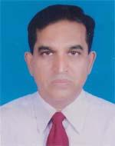 | DR. A. H. SUMON  F/Name: Late Hazi Sayedur Rahman  M/Name: Late Mrs. Valna Khatun  BM & DC Reg. No: 27324  NID: 2219447817984  Cell: 01714374354  Address: Apon Nibas, Hospital Road, Coxs Bazar  Blood Group: O+
99 | Voter No  LM-1300098  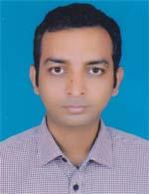 | DR. RANJAN BARUN RAJAN  F/Name: Late Dipoli Bodhi Barua  M/Name: Tandra Barua  BM & DC Reg. No: 50718  NID: 2617272279511  Cell: 01716710127  Address: Baharchara Buddhist Temple Lane, Mohajer Para, ward-09, Coxs Bazar Pourashava, Post-Coxs Bazar, Coxs Bazar Sadar, Coxs Bazar  Blood Group: B+
100 | Voter No  LM-1300099  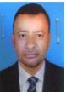 | DR. MD. BADSHA ALAMGIR  F/Name: Late Motiar Rahman  M/Name: Mrs. Alema Khatun  BM & DC Reg. No: 38702  NID: 2222412465787  Cell: 01715725114  Address: Managing Directer, Cox-National Hospital, Coxs Bazar  Blood Group: B+
101 | Voter No  LM-1300100  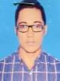 | DR. SYDOS SALMAN  F/Name: Shafiul Kabir  M/Name: Shamima Kabir  BM & DC Reg. No: 64717  NID: 1916765152654  Cell: 01857732737  Address: West New Bahar Chara, Air Port Road, Coxs Bazar  Blood Group: A+
102 | Voter No  LM-1300101 | DR. MD. MUJIBUR RAHMAN  F/Name: Late Nurul Islam  M/Name: Mrs. Shamsun Nahar  BM & DC Reg. No: 24589  NID: 19692215683242422  Cell: 01713615707  Address: UHZ Fpo, Pekha, Coxs Bazar  Blood Group: O+
103 | Voter No  LM-1300102 | DR. JAHANGIR MOHAMMAD TUFAIL UDDIN  F/Name: Sarwar Kamal  M/Name: Ismat Ara Begum  BM & DC Reg. No: 39108  NID: 2221602119005  Cell: 01676130714  Address: Medical officer Chakaria health Complex, Cox's Bazar  Blood Group: A+
104 | Voter No  LM-1300103  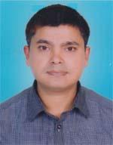 | DR. ABU ZAFAR MOHAMMAD SALIM  F/Name: A. M. M. Anwar Shah  M/Name: Late Samsun Nahar  BM & DC Reg. No: 35529  NID: 2216613669353  Cell: 01717370344  Address: Flat No. B2, Doctors Quarter, Sadar Hospital, Coxs bazar  Blood Group: B+
105 | Voter No  LM-1300104  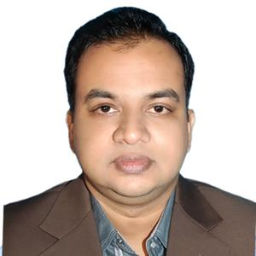 | DR MUHAMMAD ZIA UDDIN  F/Name: Emdadul Hoque  M/Name: Rasheda Begaum  BM & DC Reg. No: 33460  NID: 1978697557395690  Cell: 01717054933  Address: Rasheda manzil, Goldighir purba par, Cox's bazar  Blood Group: A+
106 | Voter No  LM-1300105 | DR. RABIUR RAHMAN  F/Name: Mvi Nurul Islam  M/Name: Sahena Islam  BM & DC Reg. No: 57947  NID: 0695111184842  Cell: 01814092298  Address: Upazilla Health Complex, Ukhia, Coxs Bazar  Blood Group: A+
107 | Voter No  LM-1300106  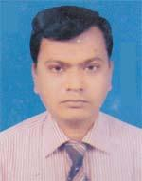 | DR. ABDUS SALAM  F/Name: Rashid Ahammed  M/Name: Late Sonameher  BM & DC Reg. No: 37502  NID: 2219415867467  Cell: 01818029291  Address: New Kabita Vaban, Central Mosque, Coxs Bazar  Blood Group: n_a
108 | Voter No  LM-1300107 | DR. AHMMADULLAH  F/Name: Md. Sirajul Islam  M/Name: Mrs. Rokeya Begum  BM & DC Reg. No: 61606  NID:  Cell: 01768235677  Address: Cox's Bazar Sadar Hospital Cox’s Bazar  Blood Group: AB+
109 | Voter No  LM-1300108  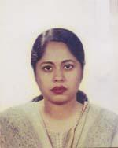 | DR. SYEDA HUMAIRA BEGUM  F/Name: Syed Shahabuddin Ahmed  M/Name: Akhtari Begum  BM & DC Reg. No: 27336  NID: 2222410360031  Cell: 01716293934  Address: Natun Kabita, Central Jame Mosjid Road, Coxs Bazar  Blood Group: n_a
110 | Voter No  LM-1300109  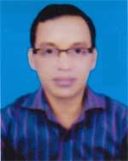 | DR. ABU MUHAMMAD SHAMSU UDDIN  F/Name: Late Syed Nur  M/Name: Alhaj Nur-e-khatun  BM & DC Reg. No: 39734  NID: 2211610038235  Cell: 01710973199  Address: Cox's Bazar Medical College  Blood Group: A+
111 | Voter No  LM-1300110  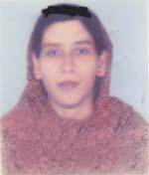 | DR. SUMAIYA EASMIN  F/Name: Md. Zillur Rahman  M/Name: Mrs. Jubeda Begum  BM & DC Reg. No: 48820  NID: 2216613669354  Cell: 01718042654  Address: Flat No. B2, Doctors Quarter, Sadar Hospital, Coxs Bazar  Blood Group: O+
112 | Voter No  LM-1300111  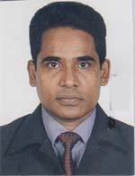 | DR. MOHAMMAD SHAHA ALAM  F/Name: Mohammad Ali Akbar  M/Name: Monowara Begum  BM & DC Reg. No: 27032  NID: 2222410360032  Cell: 01915480850  Address: Natun Kabita, Central Jame Mosque Road, Coxs Bazar  Blood Group: A-
113 | Voter No  LM-1300112 | DR. BISWAJIT ROY  F/Name: Nepal Chandra Roy  M/Name: Ratna Roy  BM & DC Reg. No: 35514  NID: 2221604160252  Cell: 01816725188  Address: Thana Centre, Chak Area M/A, Word # 4, Chakaria, Coxs Bazar  Blood Group: O+
114 | Voter No  LM-1300113  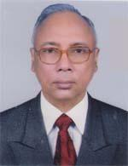 | DR. RATAN CHOWDHURY  F/Name: Late Bhupendu Bikash Chowdhury  M/Name: Late Nilima Prava Chowdhury  BM & DC Reg. No: 12096  NID: 1510476902399  Cell: 01715729217  Address: Prl. Director (OSD) Dghs. Mohakhali, Dhaka  Blood Group: AB+
115 | Voter No  LM-1300114 | DR. SAYED MARUF UR RAHMAN  F/Name: Md. Habibur Rahman  M/Name: Mina Montaj  BM & DC Reg. No: 56425  NID: 2222411459784  Cell: 01812820148  Address: 9/A, Bahar Chara, P.T.I Road, Coxs Bazar  Blood Group: B+
116 | Voter No  LM-1300115  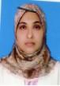 | DR. KHAIRUNNESSA  F/Name: Abu Mohammad Musa  M/Name: Mrs. Sakra Begum  BM & DC Reg. No: 32804  NID:  Cell:  Address: 41/A, Kobatwin Tower Behinel Chittagong.  Blood Group: AB+
117 | Voter No  LM-1300116  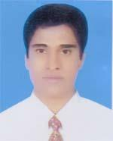 | DR. MOHAMMED SABER  F/Name: Nazir Ahamed  M/Name: Mahmuda Khatun  BM & DC Reg. No: 32036  NID: 0325102271334  Cell: 01816339231  Address: Doctors Quarter, UHC, Chakaria, Coxs Bazar  Blood Group: A+
118 | Voter No  LM-1300117  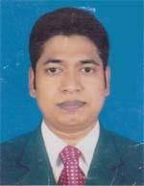 | DR. GOLAM MOSTAFA NADIM  F/Name: Joynal Abedin  M/Name: Gol Nahar Begum  BM & DC Reg. No: 60796  NID: 19874811183626084  Cell: 01717461148  Address: AN Nahar Complex, Main Road, Coxs Bazar  Blood Group: B+
119 | Voter No  LM-1300118 | DR. SAVAN DAS  F/Name: Sudash Das  M/Name: Minksai Das  BM & DC Reg. No: 63702  NID:  Cell: N/A  Address: Yekaab Upozilla Health Complex, Coxs Bazar  Blood Group: n_a
120 | Voter No  LM-1300119 | DR. SUPTA DAS  F/Name: Swapon Kumar Das  M/Name: Kalpona Das  BM & DC Reg. No: 59903  NID: 1916765152898  Cell: 01674943483  Address: Upazilla Health Complex Teknaf, Cox's bazar.  Blood Group: n_a
121 | Voter No  LM-1300120  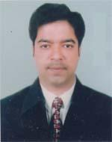 | DR. SARWAR MAHBOOB  F/Name: Late Sarwar Kamal  M/Name: Mrs. Rezia Begum  BM & DC Reg. No: 25248  NID: 2619551199721  Cell: 01715008871  Address: R-16, Zilla Porishod Banglaw, Coxs Bazar  Blood Group: O+
122 | Voter No  LM-1300121  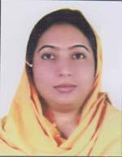 | DR. TRINA SHAHA  F/Name: Komol Kanti Shaha  M/Name: Biva Rani Shaha  BM & DC Reg. No: 43144  NID: 4820606426349  Cell: 01723969984  Address: Sadar Upazilla, Complex, Coxs Bazar  Blood Group: B+
123 | Voter No  LM-1300122  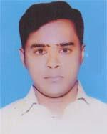 | DR. MOHAMMAD RIDOWAN TAREEN  F/Name: Mohammad Yusuf  M/Name: Mira Sabera Jabbar  BM & DC Reg. No: 50006  NID: 8524904043195  Cell: 01717734522  Address: 03, Hare Street, Wari, Dhaka  Blood Group: B+
124 | Voter No  LM-1300123  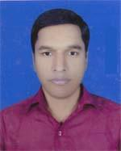 | DR. SHOVAN DUTTA  F/Name: Rakhal Krishna Dutta  M/Name: Reba Biswas  BM & DC Reg. No: 53224  NID: 8524904043250  Cell: 01816237927  Address: Chakaria Health Complex, Chakaria, Coxs Bazar  Blood Group: O+
125 | Voter No  LM-1300124 | DR. HAFIZUR RAHMAN  F/Name: Late Nurul Kabir  M/Name: Hasna Banu  BM & DC Reg. No: 36747  NID: 2222404332464  Cell: 01711983104  Address: House No. 504, Road No. 7, Baitul Aman Housing Society  Blood Group: A+
126 | Voter No  LM-1300125 | DR. MD. FARHAD HUSSAIN  F/Name: Md. Osman Goni  M/Name: Hosne Ara Begum  BM & DC Reg. No: 21561  NID: 1593511699480  Cell: 01744342467  Address: Assoc Prof Dept of Medicale Cox's Bazar.  Blood Group:
127 | Voter No  LM-1300126  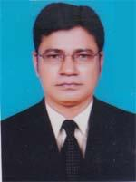 | DR. SONJOY BINUD SHARMA  F/Name: Jagadish Chandra Shil  M/Name: Nipu Rani Sharma  BM & DC Reg. No: 42816  NID: 2222410361414  Cell: 01818252957  Address: New Circuite House Road, Middle Baharchara, Coxs bazar  Blood Group: A+
128 | Voter No  LM-1300127 | DR. TUTUL TALUKDAR  F/Name: Badal Talukdar  M/Name: Rubi Talukdar  BM & DC Reg. No: 39310  NID: 1517418463154  Cell: 01894061213  Address: Resident Suraeon , 250 Bed District Sadar Hospital, Coxs Bazar  Blood Group: O+
129 | Voter No  LM-1300128 | DR. NRINMOY BISWAS  F/Name: Horipodo Biswas  M/Name: Gouri Rani Biswas  BM & DC Reg. No: 26237  NID: 9329518330746  Cell: 01727500226  Address: Hope hospital, Chainda, Ramu, Coxs Bazar  Blood Group: O+
130 | Voter No  LM-1300129  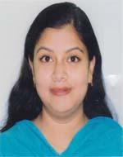 | DR. JAHANARA FERDOUS  F/Name: Md. Sohrab Hossain  M/Name: Syeda Kaniz Begum  BM & DC Reg. No: 43556  NID: 2696653266270  Cell: 01814848471  Address: Medical officer, District Sadar Hospital , Coxs Bazar  Blood Group: A+
131 | Voter No  LM-1300130  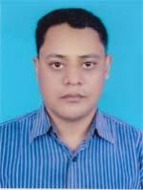 | DR. MD. MAIN UDDIN  F/Name: Mabinal Haq  M/Name: Aziza Begum  BM & DC Reg. No: 30582  NID: 2694807985947  Cell: 01728180347  Address: CIC, Hospital Road, Coxs Bazar  Blood Group: O-
132 | Voter No  LM-1300131  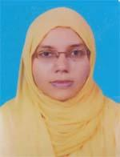 | DR. MASRUFA GULSHAN  F/Name: Md. Abdul Haque  M/Name: Aklima Khatun  BM & DC Reg. No: 47372  NID: 1518236115291  Cell: 01927708697  Address: Lecture Dept. of Microbiology Cox Bajar Medical College  Blood Group: O+
133 | Voter No  LM-1300132  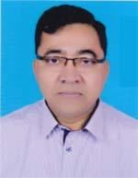 | DR. MOHAMMAD KAFIL UDDIN  F/Name: Late M. Ali Akber  M/Name: Mrs. Sabe Meraj Begum  BM & DC Reg. No: 25618  NID: 2222410361058  Cell: 01715034272  Address: CIC, Holpital Road, Coxs Bazar  Blood Group: B+
134 | Voter No  LM-1300133  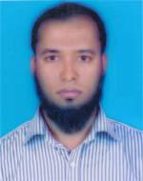 | DR. S. M. SHAHEDUL ISLAM  F/Name: Sirazul Islam  M/Name: Shaheda Begum  BM & DC Reg. No: 49482  NID: 19822222408000002  Cell: 01814786007  Address: Baidder Ghona, Coxs Bazar Sadar, Coxs Bazar  Blood Group: A+
135 | Voter No  LM-1300134  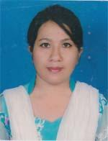 | DR. ZOSHITA BOBY  F/Name: Abdul Bari  M/Name: Zigarunnesa  BM & DC Reg. No: 44501  NID: 19802696653268881  Cell: 01975123475  Address: 3B, J.S Bhaban, Kobarstan road, South Tara Bonia Chora, Coxs Bazar  Blood Group: n_a
136 | Voter No  LM-1300135  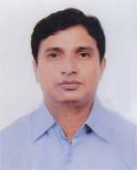 | DR. SHANGKAR BARUA  F/Name: Amal Kanti Barua  M/Name: Rina Barua  BM & DC Reg. No: 32963  NID: 2219431793841  Cell: 01943911525  Address: Lecturer Dept. of Pharma Cology, Coxs Bazar Medical College, Coxs Bazar  Blood Group: O+
137 | Voter No  LM-1300136  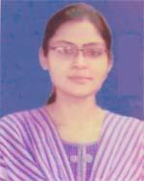 | DR. PRIYANKA DAS  F/Name: Dr. Kalipada Das  M/Name: Mrs. Panna Das  BM & DC Reg. No: 69350  NID: 9196216280210  Cell: 01722693580  Address: Shreekul , Fatekharkul , Ramu, Coxs Bazar  Blood Group: B+
138 | Voter No  LM-1300137  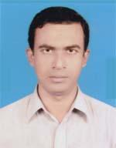 | DR. MD. MANZURUL HUQUE JEWEL  F/Name: Late Azizul Huq  M/Name: Mrs. Farida Yasmin  BM & DC Reg. No: 26938  NID: 2222410366753  Cell: 01818441787  Address: Doctors Chamber, Pan Bazar Road, Coxs bazar  Blood Group: AB+
139 | Voter No  LM-1300138 | DR. ZAHIDUL MOSTAFA  F/Name: Nurul Mostafa  M/Name: Shaheen Aktar  BM & DC Reg. No: 50530  NID: 2219031591816  Cell: 01716939633  Address: Ghorapara Road, East side of Gool Dhegee, Coxs Bazar  Blood Group: O+
140 | Voter No  LM-1300139  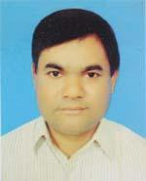 | DR. ABDUR RAHIM  F/Name: Late Nazir Ahmed  M/Name: Mrs. Susat Azam  BM & DC Reg. No: 35302  NID: 2211667004432  Cell: 01813700630  Address: Doctors Quarter, Upazilla Health Complex, Mohesh Khali, Coxs Bazar  Blood Group: O+
141 | Voter No  LM-1300140 | DR. RAJED AL HASAN  F/Name: Siddique Hossain  M/Name: Roushan Ara Begum  BM & DC Reg. No: 64864  NID: 2222410361556  Cell: 01723059015  Address: Vill-Baharchara, Post-Coxs Bazar, Upazilla-Coxs Bazar, Dist-Coxs Bazar  Blood Group: O+
142 | Voter No  LM-1300141  No Image | ***NIL***  F/Name:  M/Name:  BM & DC Reg. No:  NID:  Cell:  Address:  Blood Group:
143 | Voter No  LM-1300142 | DR. MOHAMMAD MAHFUZUL HOQUE  F/Name: Nurussafa  M/Name: Fatema Begum  BM & DC Reg. No: 36591  NID: 22149111800039  Cell: 01712124706  Address: Doctor's Quarter Upzila Health Complex, Mohenhkhali, Cox's Bazar.  Blood Group:
144 | Voter No  LM-1300143 | DR. KUHU MUSTARY  F/Name: Prof. Sumangal Mustary  M/Name: Mrs. Ratna Mustary  BM & DC Reg. No: 38509  NID: 2699501939791  Cell: 01816357165  Address: Upazilla Health Complex, Ramu, Coxs Bazar  Blood Group: A+
145 | Voter No  LM-1300144  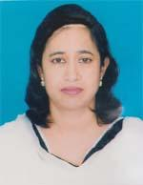 | DR. SHIRIN AKTAR JAHAN  F/Name: Md. Mokbul Hossain  M/Name: Momotaj Begum  BM & DC Reg. No: 29881  NID: 2695045900938  Cell: 01711831110  Address: Jr. Consultant (Gynee), Dist. Sadar Hospital, Coxs Bazar  Blood Group: AB+
146 | Voter No  LM-1300145 | DR. ABUL MANSUR MOHAMMAD REZAUL KARIM  F/Name: Syed Ahammad  M/Name: Sultana Rokeya Khanam  BM & DC Reg. No: 32868  NID: 19762211667008609  Cell: 01817718366  Address: Niribili Complex, Circuit House Road, Coxs Bazar  Blood Group: O+
147 | Voter No  LM-1300146  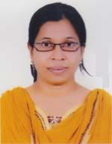 | DR. NAZMA AKTER  F/Name: Shafiqul Islam  M/Name: Rehana Begum  BM & DC Reg. No: 35033  NID: 19762211667008610  Cell: 01818142082  Address: Niribli Complex, Circuit House Road, Coxs Bazar  Blood Group: O+
148 | Voter No  LM-1300147  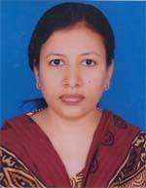 | DR. TUHIN SULTANA  F/Name: Ainul Hoque  M/Name: Sufia Hoque  BM & DC Reg. No: 37522  NID: 1594115361262  Cell: 01711371357  Address: Nabab Market, 2nd Floor. Bara Bazar Road, Coxs Bazar  Blood Group: B+
149 | Voter No  LM-1300148  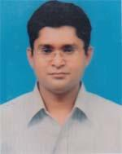 | DR. MD. ASHRAFUL ALAM  F/Name: Late Md. Nurul Alam  M/Name: Jahan Ara Begum  BM & DC Reg. No: 28783  NID: 2697556418149  Cell: 01553519743  Address: Coxs Bazar Medical College Coxs Bazar.  Blood Group: A+
150 | Voter No  LM-1300149  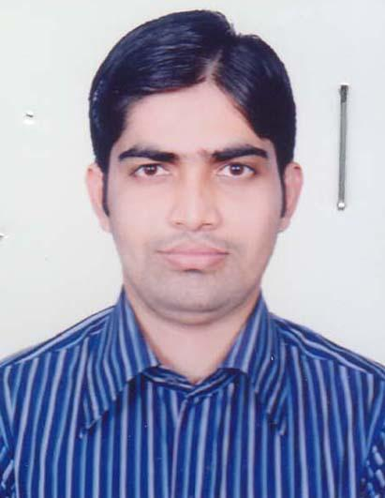 | Dr. Ahasun Ullah Sikder  F/Name: Abu Naser Sikder  M/Name: Nur Jahan Begum  BM & DC Reg. No: 85083  NID: 19922219415000259  Cell: 01750607476  Address: Vill- East Moricha, (Ward no-01), Holodia Union, Post Office: Moricha Palong (Postal Code:4750), Upazila: Ukhia, District: Cox's Bazar.  Blood Group: B+
151 | Voter No  LM-1300150  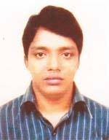 | DR. MD. MAHBUBUL ALAM  F/Name: Deras Miah  M/Name: Masuda Begum  BM & DC Reg. No: 76356  NID: 19882211622000022  Cell: 01825782809  Address: C/O Deraser Bari, Vill: Chaynammar Ghona, Post: B M Char, Upazila: Chakaria, Dist: Coxs Bazar.  Blood Group: O+

